**Adding Images to our Project**

**1. We need to add our resources to the project**

1. With a project selected in Solution Explorer, on the **Project** menu, click Properties.
2. Select the Resources tab from down the left hand side.
3. On the Resource Designer toolbar, point to Add Resource, click the arrow, and then click the type of resource you want to create.

E.g. Add Resource -> Add Existing File -> (locate file on drive)

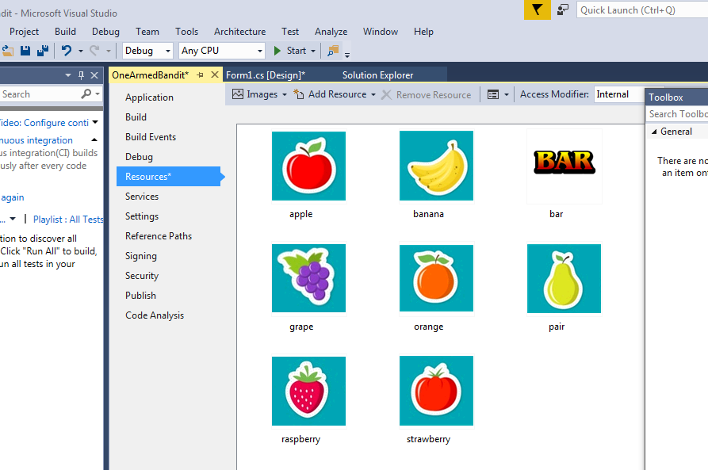

**2. Add three picture boxes to your form (about the right size for your image)**

1. Bring up Toolbox (View Toolbox)
2. Drag PictureBox over onto form. Shape/resize as necessary. Copy then paste three times

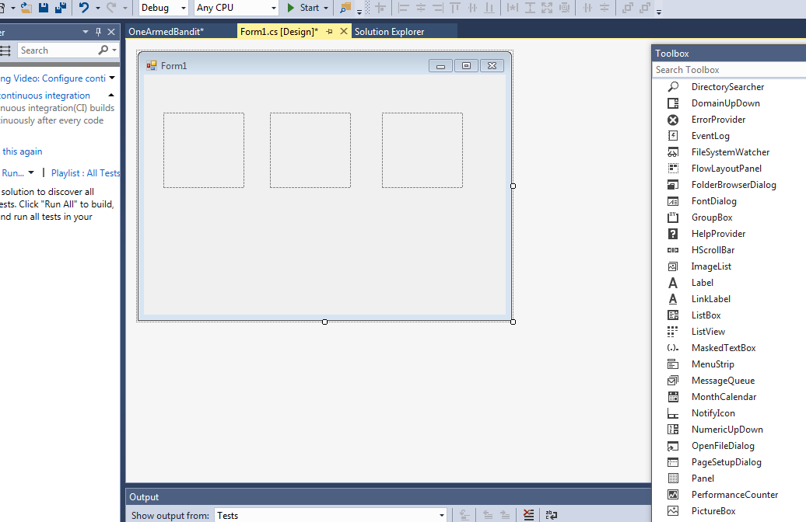

**3. The code of the above (by double clicking on form) now follows:**

using System.Windows.Forms;

**NB**

**using OneArmedBandit.Properties; // You need this to access Resources**

namespace OneArmedBandit

{

public partial class Form1 : Form

{

public Form1()

{

InitializeComponent();

}

private void Form1_Load(object sender, EventArgs e)

{

**NB**

// This code is executed when the program starts

pictureBox1.Image = Resources.raspberry;

}

}

}

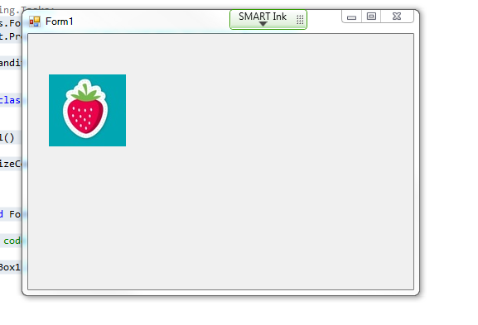

**4. Produces this:**

**Exercise**

1. Copy the directory OneArmedBandit to your own filestore.
2. Examine carefully the code in Form1 and WheelOfFruit. Notice that Form1 uses an array of three WheelOfFruit. The design can be improved further as we will see in a few weeks’ time.
3. Once you are happy with the code, you can experiment further, as follows:
   1. Write code which detects a win, and when it occurs, plays an appropriate sound.
   2. Change the code so that the nudge buttons are disabled most of the time. They should only appear be enabled randomly.
   3. When two shapes are the same on a line, there should also be some payback. Code this!
   4. Add a hold button, which when available allows you to hold a wheel.
4. For a challenge, get the images themselves to change during a spin. Look at timer.
5. Enjoy adding more, and experimenting.